Ideation Phase Empathize & Discover

Date | 08 December 2025
Team ID | SWUID60312
Project Name | Freelance Finder
Maximum Marks | 4 Marks

Empathy Map Canvas:
Understand the needs, frustrations, and behaviors of freelance professionals s
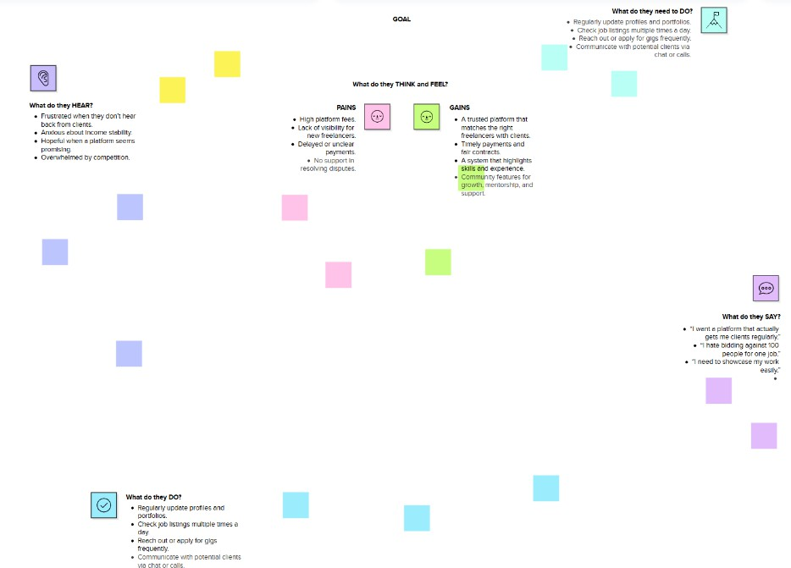
seeking consistent work through a platform like Freelance Finder.

Reference: https://www.mural.co/templates/empathy-map-canvas

